Module – 3 Practice problems part 1 (Hypothesis Testing & Type I & 2 errors)

1. We have a medicine that is being manufactured and each pill is supposed to have 14 milligrams of the active ingredient. What are our null and alternative hypotheses?

*Ho µ = 14 mg*

*Ha µ≠ 14 mg*

1. The school principal wants to test if it is true what teachers say – that high school juniors use the computer an average 3.2 hours a day. What are our null and alternative hypotheses?

*Ho µ = 3.2 hrs*

*Ha µ≠ 3.2 hrs*

1. A researcher claims that black horses are, on average, more than 30 lbs heavier than white horses, which average 1100 lbs. What is the null hypothesis, and what kind of test is this?

*The null hypothesis would be notated H0 : µ ≤ 1130 lbs This is a right-tailed test, since the tail of the graph would be on the right. Recognize that values above 1130 would indicate that the null hypothesis be rejected.*

1. A package of gum claims that the flavor lasts more than 39 minutes. What would be the null hypothesis of a test to determine the validity of the claim? What sort of test is this?

*The null hypothesis would by notated as H0 : µ ≤ 39. This is a right-tailed test, since the rejection region would consist of values greater than 39*

1. What is the critical value $\left(Z_{\frac{α}{z}}\right)$ for a 95% confidence level, assuming a two-tailed test?

*A 95% confidence level means that a total of 5% of the area under the curve is considered the critical region. Since this is a two-tailed test, 1 2 of 5% = 2.5% of the values would be in the left tail, and the other 2.5% would be in the right tail. Looking up the Z-score associated with 0.025 on a reference table, we find 1.96. Therefore, +1.96 is the critical value of the right tail and -1.96 is the critical value of the left tail. The critical value for a 95% confidence level is Z = +/−1.96*

1. Sketch the Z-score critical region for Example 5.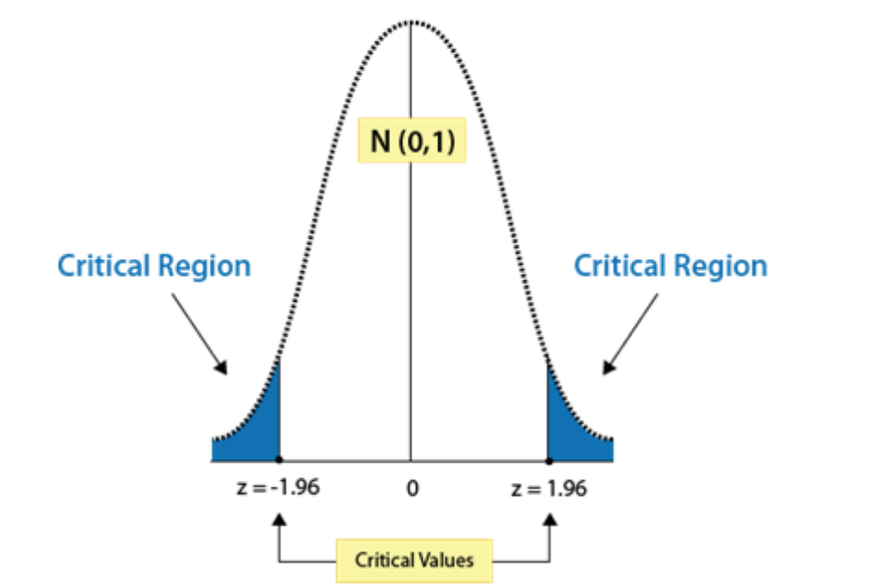
2. What would be the critical value for a right-tailed test with α = 0.01?

*If α = 0.01, then the area under the curve representing H1, the alternative hypothesis, would be 99%, since α (alpha) is the same as the area of the rejection region. Using the Z-score reference table above, we find that the Z-score associated with 0.9900 is approximately 2.33. It appears that the critical value is Z = 2.33*

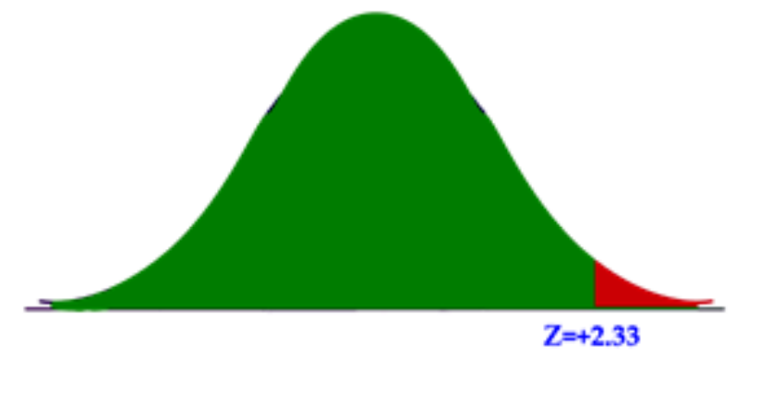

1. The school nurse thinks the average height of 7th graders has increased. The average height of a 7th grader five years ago was 145 cm with a standard deviation of 20 cm. She takes a random sample of 200 students and finds that the average height of her sample is 147 cm. Are 7th graders now taller than they were before? Conduct a single-tailed hypothesis test using a .05 significance level to evaluate the null and alternative hypotheses.

*H0 : µ ≤ 145 Ha : µ > 145*

*Choose α = .05. The critical value for this one tailed test is z=1.64. This is a one-tailed test, and a z-score of 1.64 cuts off 5% in the single tail. Any test statistic greater than 1.64 will be in the rejection region*

*Next, we calculate the test statistic for the sample of 7th graders. z = 147−145 √ 20 200 ≈ 1.414 The calculated z−score of 1.414 is smaller than 1.64 and thus does not fall in the critical region. Our decision is to fail to reject the null hypothesis and conclude that the probability of obtaining a sample mean equal to 147 is likely to have been due to chance.*

1. A farmer is trying out a planting technique that he hopes will increase the yield on his pea plants. The average number of pods on one of his pea plants is 145 pods with a standard deviation of 100 pods. This year, after trying his new planting technique, he takes a random sample of his plants and finds the average number of pods to be 147. He wonders whether or not this is a statistically significant increase. What are his hypotheses and the test statistic?

*H0 : µ ≤ 145 Ha : µ > 145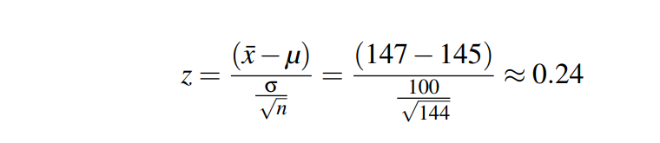*

*If we choose α = .05 4. The critical value will be 1.645. We will reject the null hypothesis if the test statistic is greater than 1.645. The value of the test statistic is 0.24. 5. This is less than 1.645 and so our decision is to fail to reject H0. Based on our sample we believe the mean is equal to 145.*

1. The high school athletic director is asked if football players are doing as well academically as the other student athletes. We know from a previous study that the average GPA for the student athletes is 3.10. After an initiative to help improve the GPA of student athletes, the athletic director randomly samples 20 football players and finds that the average GPA of the sample is 3.18 with a sample standard deviation of 0.54. Is there a significant improvement? Use a 0.05 significance level.

*H0 : µ = 3.10 Ha : µ 6= 3.10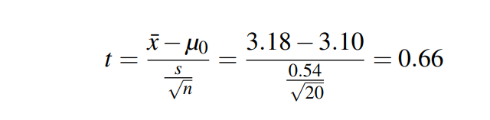*

*We know that we have 20 observations, so our degrees of freedom for this test is 19. Nineteen degrees of freedom at the 0.05 significance level gives us a critical value of ± 2.093.*

*Thus, the athletic director can conclude that the mean academic performance of football players does not differ from the mean performance of other student athletes.*

1. Duracell manufactures batteries that the CEO claims will last an average of 300 hours under normal use. A researcher randomly selected 20 batteries from the production line and tested these batteries. The tested batteries had a mean life span of 270 hours with a standard deviation of 50 hours. Do we have enough evidence to suggest that the claim of an average lifetime of 300 hours is false?

*H0 : µ = 300 HA : µ 6= 300*

*Standard Error: SEx¯ = √s n SEx¯ = √ 50 20 = 11.18*

*t = x¯−µ SEx¯ = 270−300 11.18 = −2.68*

*We know that we have 20 batteries, so our degrees of freedom for this test is (20-1)= 19. Nineteen degrees of freedom at the 0.05 significance level gives us a critical value of ± 2.093*

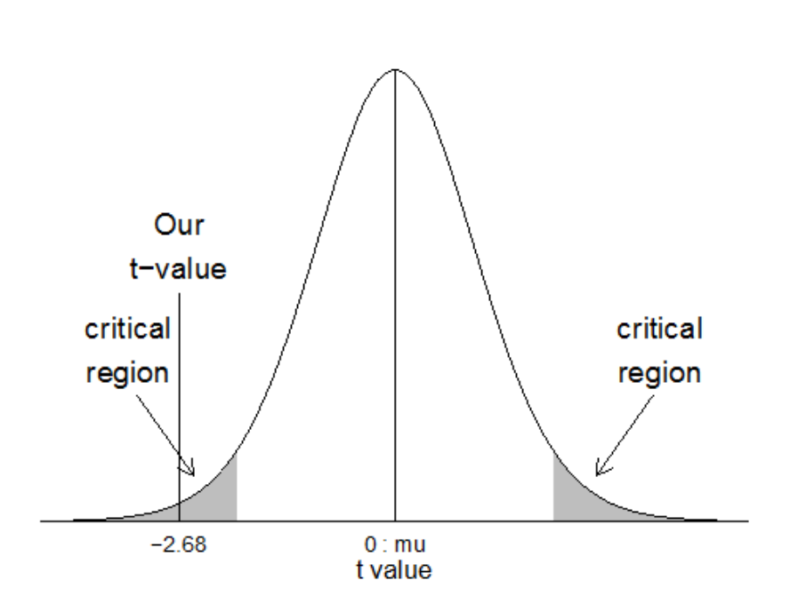

*The average battery life of the sample is significantly different from the average battery life claim by the CEO.*

1. You have just taken ownership of a pizza shop. The previous owner told you that you would save money if you bought the mozzarella cheese in a 4.5 pound slab. Each time you purchase a slab of cheese, you weigh it to ensure that you are receiving 72 ounces of cheese. The results of 7 random measurements are 70, 69, 73, 68, 71, 69 and 71 ounces. Are these differences due to chance or is the distributor giving you less cheese than you deserve?

a. State the hypotheses.

b. Calculate the test statistic.

c. Would the null hypothesis be rejected at the 10% level? The 5% level? The 1% level?

*a. H0 : µ = 72; and for Ha : µ ≠ 72.*

*b. -2.9315.*

*c. The null hypothesis would be rejected at the .10 and the .05 levels, but not at the .01 level.*

1. The average weight of a dumbbell in a gym is 90lbs. However, a physical trainer believes that the average weight might be higher. A random sample of 5 dumbbells with an average weight of 110lbs and a standard deviation of 18lbs. Using hypothesis testing check if the physical trainer's claim can be supported for a 95% confidence level.

*The average weight of the dumbbells may be greater than 90lbs*

1. The average score on a test is 80 with a standard deviation of 10. With a new teaching curriculum introduced it is believed that this score will change. On random testing, the score of 38 students, the mean was found to be 88. With a 0.05 significance level, is there any evidence to support this claim?

*There is a difference in the scores after the new curriculum was introduced.*

1. The average score of a class is 90. However, a teacher believes that the average score might be lower. The scores of 6 students were randomly measured. The mean was 82 with a standard deviation of 18. With a 0.05 significance level use hypothesis testing to check if this claim is true.

*There is not enough evidence to support the claim.*

1. A stenographer claims that she can take dictation at the rate of 120 words per minute. Can we reject her claim on the basis of 100 trials in which she demonstrated a mean of 116 words with standard deviation of 15 words ?

*Claim rejected*

1. An automatic machine was designed to pack exactly 2 kg. of tea. A sample of 100 packs was examined to test the machine. The average weight was found to be 1.94 kg. with standard deviation of 0.10 kg. is the machine working properly ?

*The machine is not working properly*

1. A sample of 600 persons selected at random from a large city shows that there are 53% smokers. Is there any reason to doubt the hypothesis that smokers and non-smokers are equal in number in the city ?

*smokers and non-smokers are equal in numbers in that city*

1. When flipped 1000 times, a coin landed 515 times heads up. Does it support the hypothesis that the coin is unbiased ?

*The coin is not unbiased*

1. While throwing 5 die 40 times, a person got success 25 times - getting a 4 was called success. Can we consider the difference between expected value and observed value as being significantly different ?

*The dice is not unbiased*

1. A patented medicine claimed that it is effective in curing 90% of the patients suffering from malaria. From a sample of 200 patients using this medicine, it was found that only 170 were cured. Determine whether the claim is right or wrong. (Take 1% level of significance).

*The claim is justified*

1. A random sample of 400 male students have average weight of 55 kg. Can we say that the sample comes from a population with mean 58 kg. with a variance of 9 kg. ?

*The sample is not likely to be from the given population*

1. A random sample of 400 tins of vegetable oil and labeled "5 kg. net weight" has a mean net weight of 4.98 kg. with standard deviation of 0.22 kg. Do we reject the hypothesis of net weight of 5 kg. per tin on the basis of this sample at 1% level of significance ?

*Accepted at 1% level of significance*

1. The maximum probability of committing a Type I error is

*A. also the level of significance*

*B. never more than 0.05*

*C. the power of the test*

*D. zero if the null hypothesis is rejected*

1. Which of the following is a correct statement (in the context of hypothesis tests)?

*A. The Power of a test increases as the Type 2 error probability does*

*B. It is not possible to decrease both Type 1 error and Type 2 error at the same time.*

*C. The significance level is always equal to the probability of Type 2 error.*

*D. A test is significant if it fails to reject the null hypothesis.*

1. Bottles of water have a label stating that the volume is 12 oz. A consumer group suspects the bottles are under‐filled and plans to conduct a test. A Type I error in this situation would mean

*A. the consumer group concludes the bottles have less than 12 oz. when the mean actually is 12 oz.*

*B. the consumer group does not conclude the bottles have less than 12 oz. when the mean actually is less than 12 oz.*

*C. the consumer group has evidence that the label is incorrect.*

1. The owner of travel agency would like to determine whether or not the mean age of the agency's customers is over 24. If so, he plans to alter the destination of their special cruises and tours. If he concludes the mean age is over 24 when it is not, he makes a _______ error. If he concludes the mean age is not over 24 when it is, he makes a ______error.

*A) Type II; Type II*

*B) Type I; Type I*

*C) Type I; Type II*

*D) Type II; Type I*

1. Suppose we wish to test H : 53 vs H : 53 0 µ ≤ a µ > . What will result if we conclude that the mean is greater than 53 when its true value is really 55?

*A) We have made a Type I error*

*B) We have made a correct decision*

*C) We have made a Type II error*

*D) None of the above are correct*

1. A hypothesis test is used to prevent a machine from underfilling or overfilling quart bottles of beer. On the basis of sample, the machine is shut down for inspection. A thorough examination reveals there is nothing wrong with the filling machine. From a statistical point of view:

*A) Both Type I and Type II errors were made.*

*B) A Type I error was made.*

*C) A Type II error was made.*

*D) A correct decision was made.*

1. A bottling company needs to produce bottles that will hold 12 ounces of liquid. Periodically, the company gets complaints that their bottles are not holding enough liquid. To test this claim, the bottling company randomly samples 36 bottles. Suppose the p-value of this test turned out to be 0.0455. State the proper conclusion.

*A) At α = 0.085, fail to reject the null hypothesis.*

*B) At α = 0.035, accept the null hypothesis.*

*C) At α = 0.05, reject the null hypothesis.*

*D) At α = 0.025, reject the null hypothesis.*

1. Which of the following are A/B Testing tools?

*A. Visual Website optimizer*

*B. Google Content Experiments*

*C. Optimizely*

*D. All of the above*

1. Always perform A/B Testing if there is probability to beat the original variation by?

*A. 0.05*

*B. less than 5%*

*C. greater than 5%*

*D. greater than equal to 5%*

1. A weight reducing program that includes a strict diet and exercise claims on its online advertisement that it can help an average overweight person lose 10 pounds in three months. Following the program’s method a group of twelve overweight persons have lost 8.11 5.7, 11.6, 12.9, 3.8, 5.9, 7.8, 9.1, 7.0, 8.2, 9.3 and 8.0 pounds in three months. Test at 5% level of significance whether the program’s advertisement is overstating the reality.

*Program is overstating the reality*

1. A ketchup manufacturer is in the process of deciding whether to produce an extra spicy brand. The company’s marketing research department used a national telephone survey of 6000 households and found the extra spicy ketchup would be purchased by 335 of them. A much more extensive study made two years ago showed that 5% of the households would purchase the brand then. At a 2% significance level, should the company conclude that there is an increased interest in the extra-spicy flavour?

*Current interest is significantly greater than the interest 2 years ago.*

1. A sample of 32 money market mutual funds was chosen on January 1, 1996 and the average annual rate of return over the past 30 days was found to be 3.23% and the sample standard deviation was 0.51%. A year earlier a sample of 38 money-market funds showed an average rate of return of 4.36%. Is it reasonable to conclude (at α = 0.05) that money-market interest rates declined during 1995?

*Reject Ho*

1. A large hotel chain in trying to decide whether to convert more of its rooms into non-smoking rooms. In a random sample of 400 guests last year, 166 had requested the non-smoking rooms. This year 205 guests in a sample of 380 preferred the non-smoking rooms. Would you recommend that the hotel chain convert more rooms to non-smoking? Support your recommendation by testing the appropriate hypotheses at 0.01 level of signifaicance.

*Convert more rooms to Non-smoking*